**Scope Management Plan**

**RAM-IT: ITRO’s ChatBot & Ticketing System**

**Asia Pacific College**

**3 Humabon Place, Magallanes**

**Makati City 1232 PH**

**May. 03, 2023**

**Table of Contents**

Introduction 4

Scope Management Approach 5

Roles and Responsibilities 5

Scope Definition 7

Project Scope Statement 7

Work Breakdown Structure 8

Scope Verification 9

Scope Control 10

Sponsor Acceptance 11

# Introduction

The RAMIT scope management plan will provide an overview of the best practices and modern instruments that will be used to specify, record, and manage the project's scope. The project team will be able to use agile approaches and real-time collaboration technologies to provide a cutting-edge tool that satisfies the requirements of all the stakeholders that are involved.

The scope of RAMIT will be defined through the following activities:

Requirements gathering: The project team will employ a number of methods to collect and Include user interviews, focus groups, and online surveys while documenting the system's needs.

User stories: In order to describe the functionality of the project, the project team will generate user stories. system from the viewpoint of the ultimate user. The order of these stories will be determined by the development process and it will be guided by the business value.

Verify Scope: The requirements and user stories will be used as input to verify the scope. It will give a high-level summary of the project scope, including the deliverables, exclusions, and restrictions.

Control Scope: By including the verification of the scope, the control scope will be established. project management strategy, as well as the user stories. As the information is updated, the Project progresses to account for scope changes.

# Scope Management Approach

The scope of RAMIT will be documented in the following ways:

Requirements documentation: The system's specifications will be outlined in a specifications document for requirements.

Project management plan: The scope is a component of the project management plan. the scope baseline and any other pertinent details regarding the extent of the project.

Backlog: A Backlog will be maintained to track all changes to the scope of the project, including the description of the change, the impact on the project, and the required approvals.

The scope of RAMIT will be controlled through the following activities:

Scope verification: Agile testing methods will be used by the team to ensure that the project's deliverables are compliant with the specifications and follow the stated scope.

Scope change control: Project scope modifications will be handled through a formal change control procedure that includes an evaluation of the effect on the Schedule, budget, and quality of the project. Scope

Scope change review: Each change request will be the subject of a scope change review. Verify that the change is required, practicable, and in line with the project's goals.

# Roles and Responsibilities

Project Manager: Jayson Q. Aloya – Responsible for leading the team and project to success by ensuring everyone is doing their part to the best quality. Responsible for communicating with the Stakeholders and the Project Sponsor. Responsible for checking if the documents are consistent with one another.

Head of Back End Programming: Marc E. Zamora – Responsible for the UX and coding of the features for RAM-IT.

Head of Front End Programming: Marc Julian D. Sajul – Responsible for the UI and coding of the visuals for RAM-IT.

Documentation Team: John Christopher T. Langcauon – Responsible for documents made for the project. Responsible for writing the minutes of the meeting. Responsible for compilation of documents.

Documentation Team: Jan Gabriel B. Prion – Responsible for documents made for the project.

Project Sponsor: Jojo F. Castillo – Responsible for approving documents.

Project Adviser: Jo Anne M. de la Cuesta – Responsible for advising the team on decisions. Responsible for checking documents to ensure that everything is consistent with quality and coherence.

Information Technology Resource Office – Will benefit from RAM-IT as it is made to increase quality and improve their customer services.

Asia Pacific College Members – Will benefit from the services provided by RAM-IT once implemented by the ITRO.

# Scope Definition

The Ticketing system can decrease the margin of unsolved problems that aren't solved yet or problems that hasn't seen the light of day. The opportunity to increase the number of these inquiries to be solved by the ITRO by making a system that can sort, centralize, and manage the inquiries in a single system.

# Project Scope Statement

* Product Scope Description – project RAM-IT aims to provide the ITRO a better way of providing customer service through a chatbot and ticketing system.
* Product Acceptance Criteria – In order for the project to be officially completed, the following acceptance criteria should be met:

|  |  |  |  |
| --- | --- | --- | --- |
| As a/an… | I want to… | So that… | Acceptance Criteria |
| APC Community Member | Log in to my account | I can access my account | APC Community Member logs into RAM-IT to access their account.  Given that I will log in  When I click the login button  Then I can access my account |
| APC Community Member | Inquire via ChatBot | I can have an immediate response to my inquiry | APC Community Member inquires via ChatBot to receive a quick response  Given that I will inquire via chatting with the ChatBot  When I click the hovering chat bot, then “type a message”  Then my inquiry will be given a quick response by the ChatBot |
| APC Community Member | Submit a ticket | I can be provided service for my inquiry by ITRO | APC Community Member submits a ticket via the ticketing system  Given that I will proceed to turn my inquiry into a ticket  When I click “Submit a Ticket”  Then I had submitted a request ticket that will be received by the ITRO |
| ITRO Supervisor | Assign a ticket | I can assign an ITRO Specialist to handle a ticket | ITRO Supervisor assigns a request ticket to an ITRO Specialist  Given that I’m able to assign a ticket to an ITRO Specialist  When I click “Assign” and choose an ITRO Specialist  Then I can proceed sending the assigned request ticket to an ITRO Specialist |
| ITRO Specialist | Receive a reminder notification | I can respond to the ticket as soon as possible | ITRO Specialist receives a reminder notification regarding their assigned request ticket  Given that I have not provided action to an assigned request ticket  When RAM-IT monitors an assigned request ticket and sees it is still not given action  Then I will receive a reminder notification |
| ITRO Specialist | Use the Ticket Chat | I can respond to the APC Community Member’s inquiry | ITRO Specialist uses a ticket chat to communicate with an APC Community Member regarding their inquiry  Given that I am communicating and providing service to an APC Community Member  When I write a message and press the send button  Then my message will then be sent to the APC Community Member |
| ITRO Supervisor | Manage the tickets | I can close open tickets and review closed tickets | ITRO Supervisor manages the ticket inside the ticketing system  Given that APC Community Member’s inquiry is satisfied  When “Close Ticket” is clicked  Then I can close the ticket and review closed tickets |
| ITRO Supervisor | Adding Response to ChatBot | I can add response to the database of the ChatBot | ITRO Specialist adds a response to the database of the ChatBot  Given that they have a solution to an inquiry not yet in the database  When I press “Add to database” after inputting the inquiry and solution  Then the response will be added to the database |
| ITRO Supervisor | Receive RAM-IT’s Ticket Report | I can have reports on the APC Community Members’ tickets | ITRO Supervisor receives the ticket report produced by RAM-IT  Given that there are tickets  When ITRO Supervisor clicks “download data”  Then the system will produce a report of all the tickets |

* Project Deliverables – the project deliverables can be seen in the work breakdown structure. This includes documents and the prototype.

**Project Deliverables**

1. Project Exclusions – The project requires personal computer whether desktop or laptop for each team members throughout the completion of the project.
2. Project Constraints – The project is done mainly by five team members, their project sponsor/client, and their adviser. The project is set to finish on the month of June, on the year 2023. The total project cost will be ₱913,006.16. With the help of their sponsor, they will achieve completion of the project, although assurance that all the plans and budget will be followed is strictly monitored.
3. Project Assumptions – Most of the assumption made by the team is the cost estimate.

# Work Breakdown Structure

The Work Breakdown Structure shows the Summary Tasks and Work Packages that are needed to be done through the whole process of the project RAM-IT: ITRO’s ChatBot & Ticketing System.

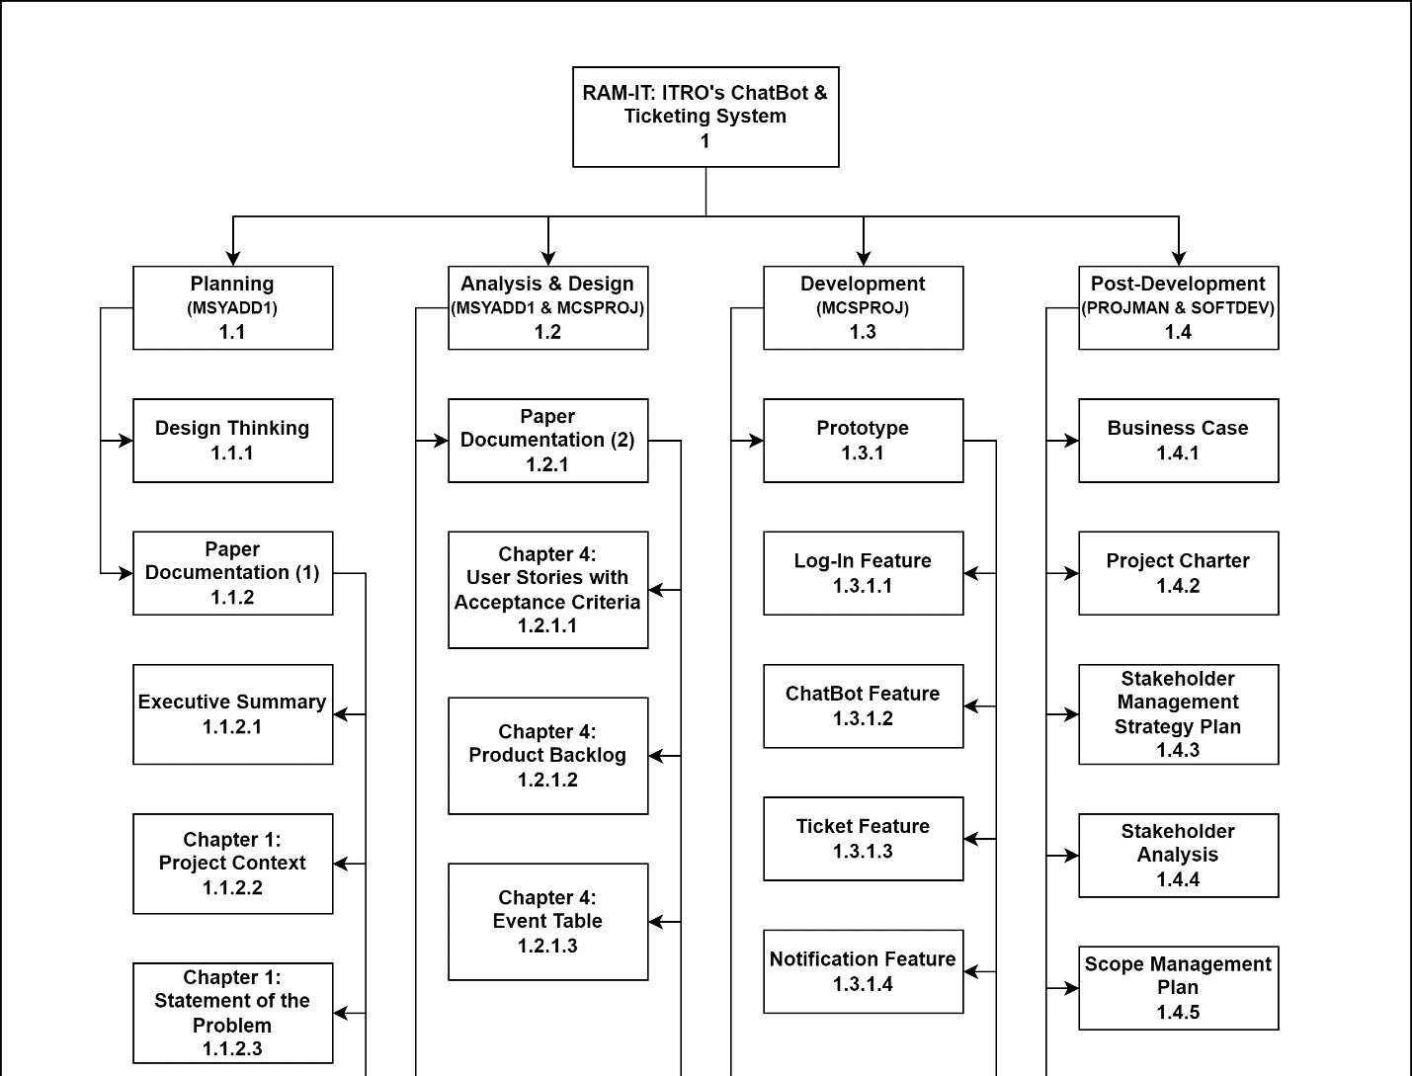

**Figure 1.1, *Work Breakdown Structure (WBS) (1)***

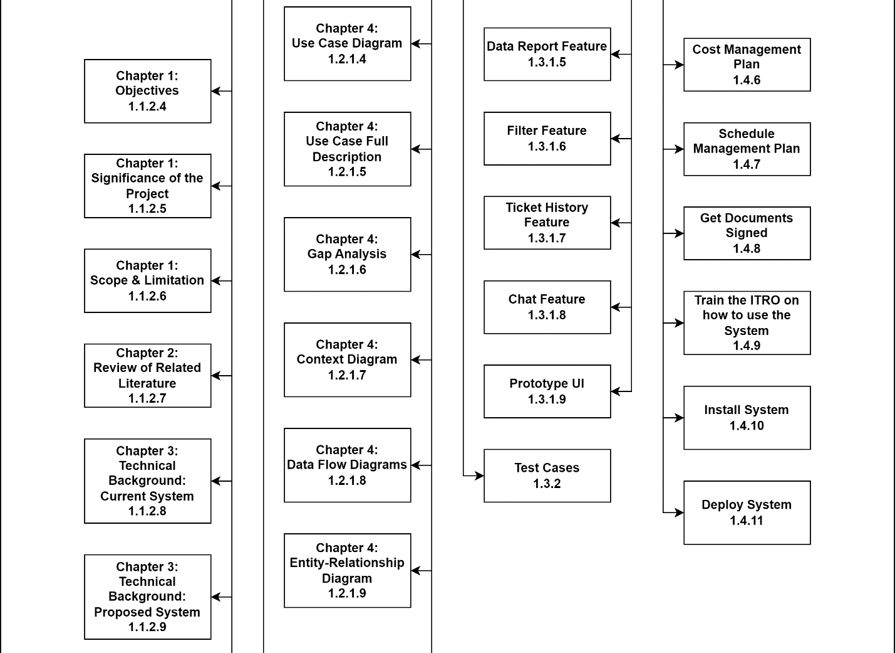

**Figure 1.2, *Work Breakdown Structure (WBS) (2)***

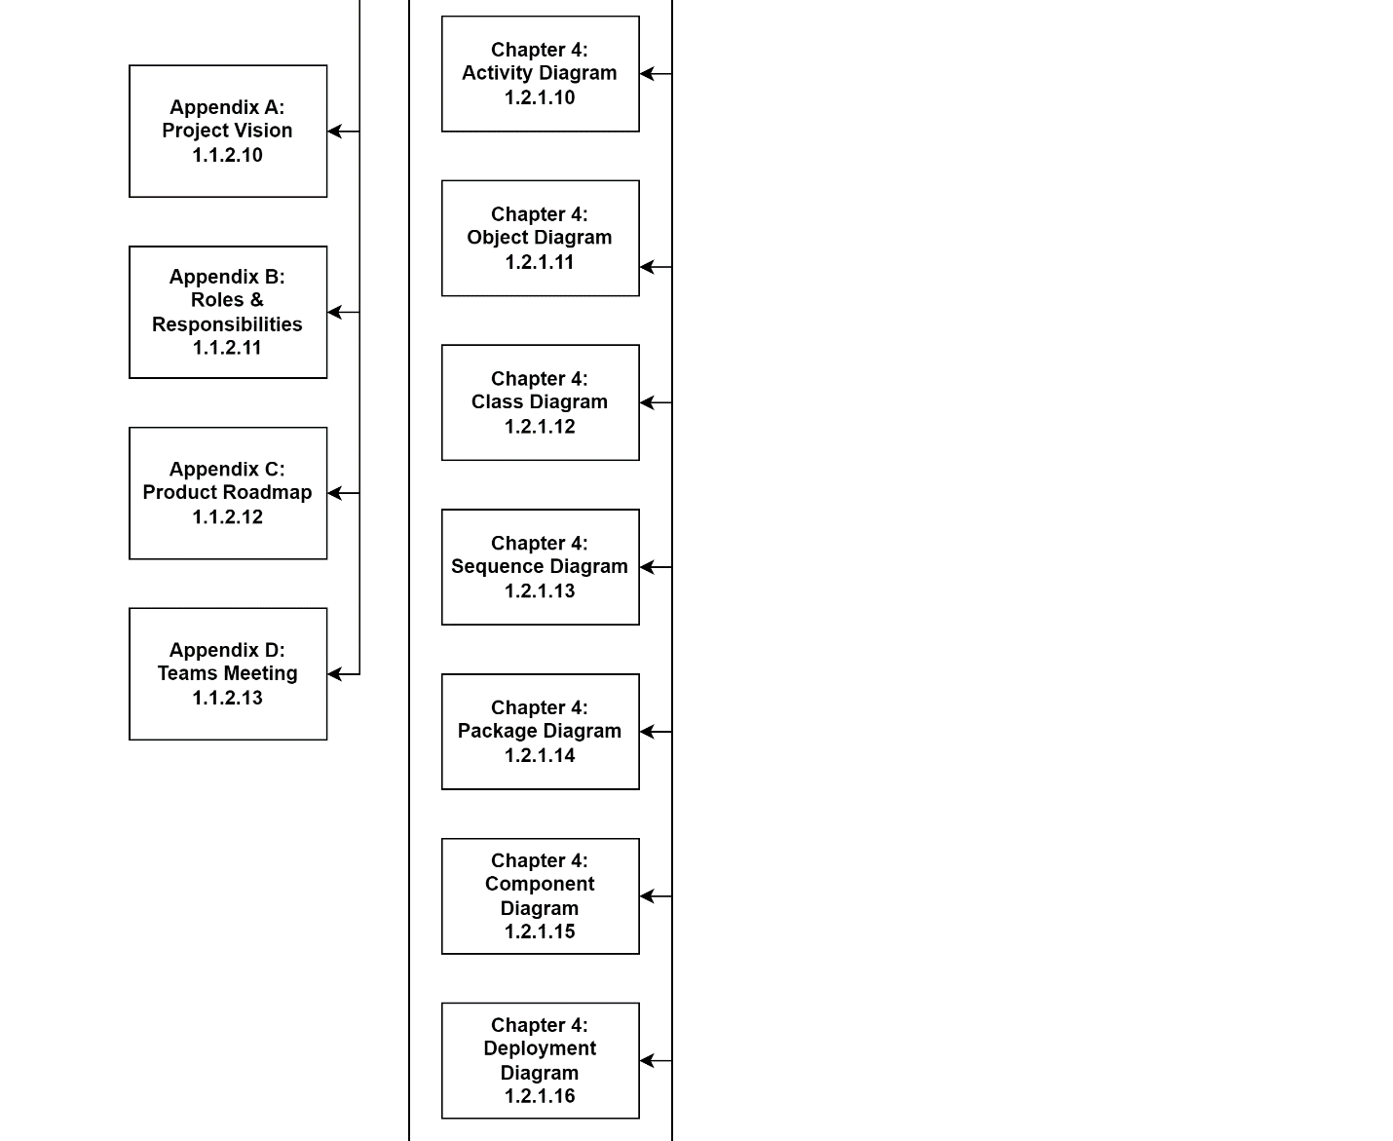

**Figure 1.3, *Work Breakdown Structure (WBS) (3)***

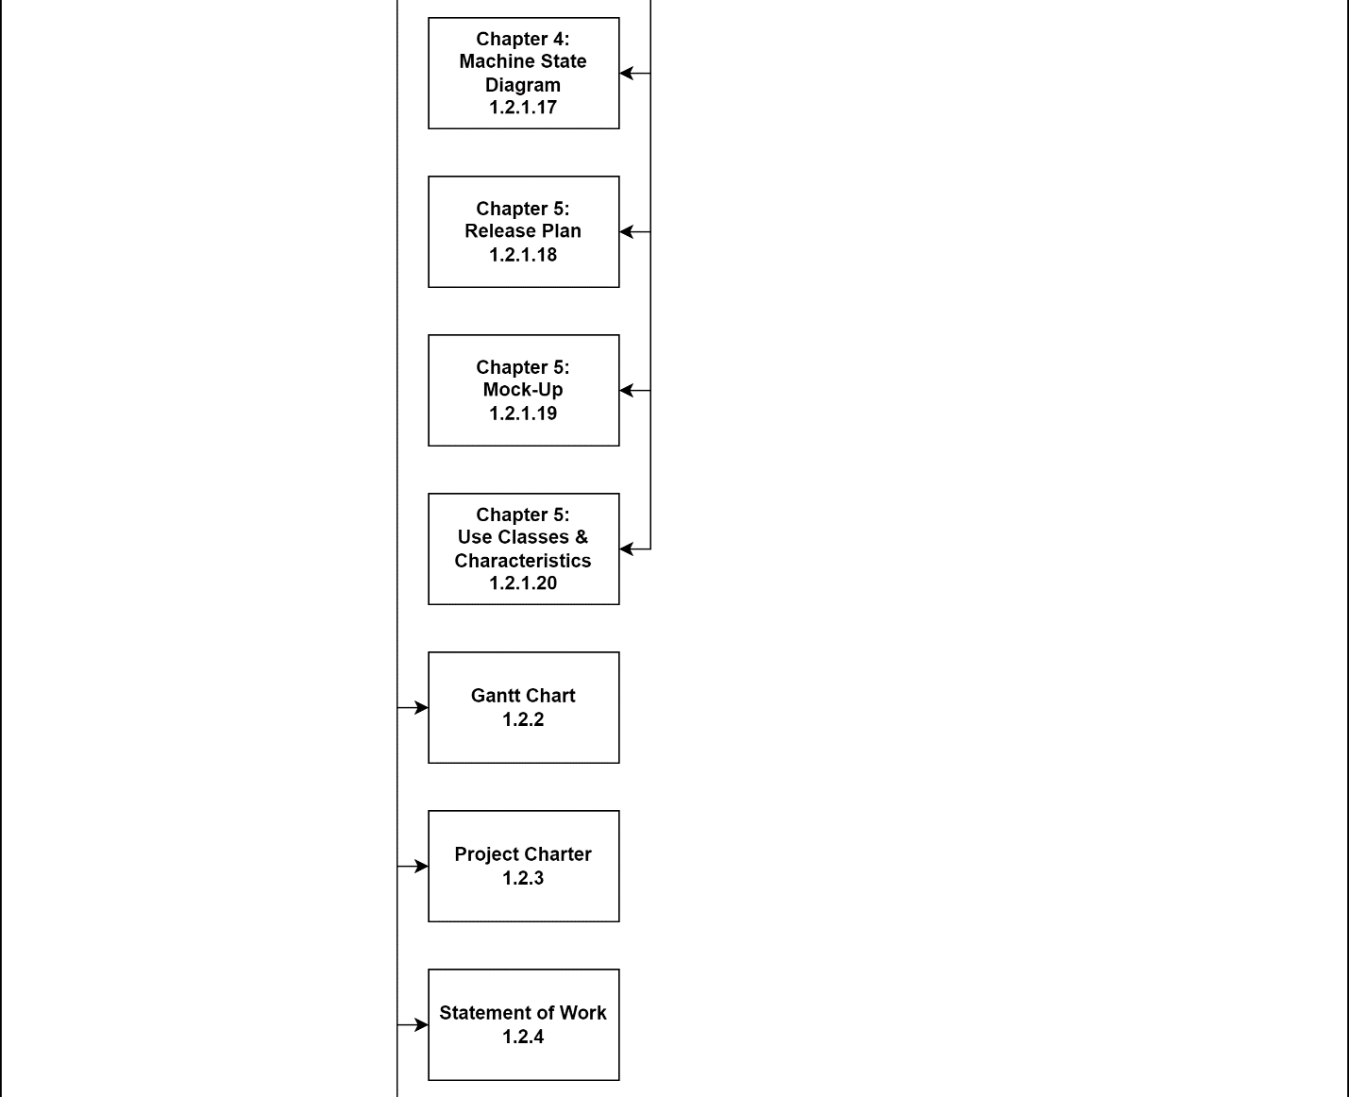

**Figure 1.4, *Work Breakdown Structure (WBS) (4)***

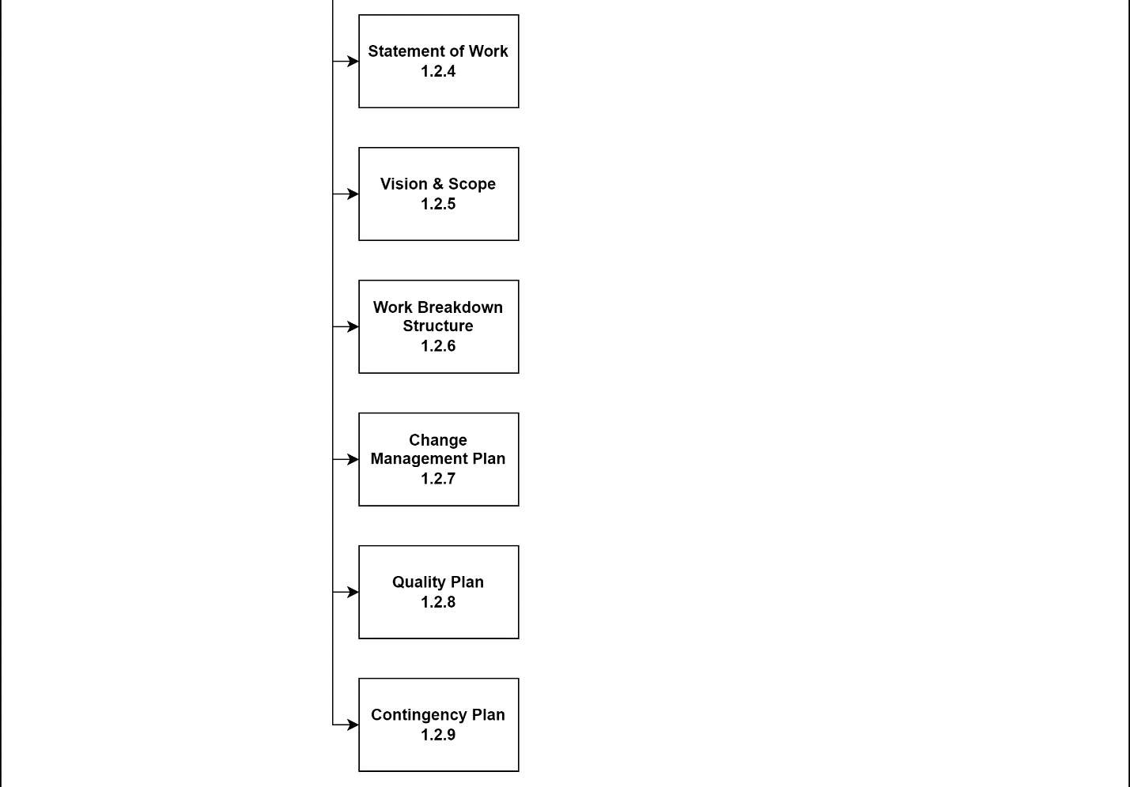

**Figure 1.5, *Work Breakdown Structure (WBS) (5)***

# Scope Verification

The scope will be verified through the usage of agile methodology as team ensures every document is within the scope. If changes were to be made, it should undergo a process of approval first.

Methods to ensure that all documents and deliverable are consistent with the scope of the project are the following:

Quality Assurance Checklist:

The scope will be tracked using the backlog. Changes within the scope, once approved will be included in the backlog. Status of completion will also be seen in the backlog.

Scope Baseline:

The scope baseline is set at the beginning of the project. The scope can still change as long as it undergoes the process, but the main goal still will shape the scope. This ensures changes that are too big and too far from the original purpose of the project will not drastically affect the project since it can be stopped at the approval process in which the project manager can check the scope baseline to check if it is too big and unnecessary of a change.

# Scope Control

The scope will be monitored by the team, especially the one responsible for quality assurance which is one of the documentation team members. They will monitor the status and track changes that will directly go to the backlog once approved by the project manager.

In order to make changes in the scope, a process using the change management plan will occur so that the change will be documented before it will be sent for approval to the project manager.

Approved by the Project Sponsor:

Date:

Mr. Jojo F. Castillo

Executive Director, Technical Services Director,

Administrative Support Services